Frozen Summer: Oghuz Edition
Finish them! If you can…

Design Document
(Homework No.2)

Project team: Rush B
Submitted in partial fulfillment of the requirements of the CSCI 4836: Game Development Fundamentals course project

Version date | Version information
19.10.2018 | Initial draft
21.10.2018 | Final Draft

Other documents in the package
File name | Brief description of the document
Final Diagram | .vsdx file that contains our game diagram
<File name> | <Description of the document>

Team member | Contribution to this homework (NOT the project) | Estimated %
<Student Name 1> | <Description of the work contributed> | <X>%
<Student Name 2>
<Student Name 3>
<Student Name 4>

Table of Contents
Table of Contents 2
1. Introduction 2
2. Player Elements 2
Player Definition 2
Player Properties 3
Player Rewards (Power-ups & Pick-ups) 3
3. User Interface (UI) 3
Heads up Display (HUD) 4
Player View 5
4. Antagonistic Elements 5
Antagonistic Definitions 6
Antagonistic Properties 6
Antagonistic List 6
Artificial Intelligence (AI) 6
5. Global Game Elements 7
The Story 7
The Story Copy 7
Concept Art 7
Level Design 7
Level Copy 7
Audio & Sound F/X 7
6. Game Architecture 7
Game Architecture Overview 7
Architecture Copy 7
How to Play Copy 8
7. References 8

Introduction
This is part of the Game Design Document for a hypothetical project <Game Project Name> submitted for partial fulfillment of the requirements of the Game Development Fundamentals course in the School of Information Technologies and Engineering at ADA University, Baku, Azerbaijan.
Since, shooter gaming is most popular genre among the video game players, we decided to choose this genre. Users of our game are going to fight against the bots via shooting snowballs to them. Main players will have different abilities based on their roles. Our game will have gloomy atmosphere in order to catch the player’s more attention. In our map 3D models such as buildings of ADA University, Flame towers of Azerbaijan will be included. Our players have to defeat each “snowman” to access new levels. This game basically is going to be “nationalized” version of the Snow Craft. [1]
After the starting Frozen Summer game the user will be able to see his/her nickname, list of the characters, game sound settings, etc. in the main menu.
When the user starts to play, he/she will begin with low difficult level. In order to survive in our game character must avoid shootings from snowball and finish them in a given time.
Since our game is going to have 3 different levels, difficulty is going to change accordingly.
For instance, in next levels given time to finish the snowmen will decrease and power of the snowmen will increase. Our game will have life level bar, when it reaches below the certain level, movement ability of the character will decrease and as soon as life level bar reaches the zero, game will be over. The user have to start from first level when his/her character dies.
The game will be non-violent, so there is not going to be blood, or other graphic content while playing against the bots.

“Frozen Summer” activity modules
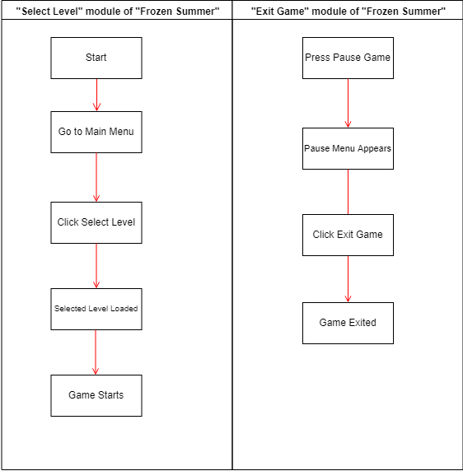

Game matrix

Element ID | Name | Description
001 | Basat | One of the game characters that have special ability to move fast
002 | Beyrek | A game character that can shoot multiple snowball at the same time
003 | Bay Becan | A game character that have powerful snowballs
004 | Simnar Khan | Main enemy in the last level that have highest power
005 | Buildings | There is going to be several buildings that users can use them as a protection from snowballs.
006 | Snowball | An item that can reduce life level by 10 point when it collides with user
007 | Life level boost | There will be multiple heart shaped items across the map where user can increase the life level of the character
008 | Snowmen | Enemies of the amin character, lower power/ability compared to Simnar Khan

Game Flow Chart

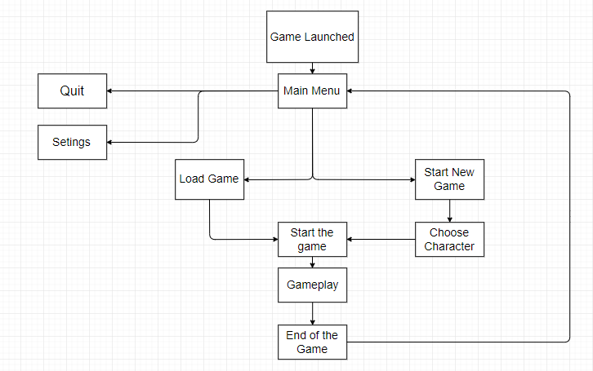
Since, shooter gaming is most popular genre among the video game players, we decided to choose this genre. Users of our game are going to fight against the bots via shooting snowballs to them. Main players will have different abilities based on their roles. Our game will have gloomy atmosphere in order to catch the player’s more attention. In our map 3D models such as buildings of ADA University, Flame towers of Azerbaijan will be included. Our players have to defeat each “snowman” to access new levels. This game basically is going to be “nationalized” version of the Snow Craft. [1]

Player Elements

Our project is going to have player and graphic elements. As we mentioned before, our game will have different characters and the user will be able to choose the desired one. Since main characters: Basat, Beyrek, Bay Becan are heroes from Azerbaijani fairy tales, we will have 3D version of them in national dress.

Player Definition

• Default (Status): At the beginning of the game, sound and music will be on default. Each character is going to have 100 percent life level and their special characteristics will be loaded on automatically.
• Actions: The main character is going to shoot snowmen with snowball. The main player has to move constantly in order to avoid getting shoot back from snowmen.
• Information (Status): If main player gets shot by snowmen the player’s energy level is going to decrease. For restoring life level, main player has to find and collect special points which is indicated with heart shape.
• Default Properties: At the beginning of the game the user will choose right character for him/her.
• Winning: The main character which defeated all snowmen in given time will be winner. The player can win the game with shooting multiple snowball to the snowmen.
• Losing: The player who got shot by snowmen lose the game when life level reaches zero.

Player Properties

Each character is going to have its own properties. For instance, as we stated before Basat will have ability move fast, Bay Becan will equip with more powerful snowballs, etc. The player have to avoid being shot by snowmen and finish them in a given time, in order to get access to the next level. List of players definitions are:
- 100% Health level
- Collecting heart shaped items to increase life level
- Snowballs
- Using buildings as a shield

Player Rewards (Power-ups & Pick-ups)
During the game if the player shoot the enemy 3 times without a miss, character’s points will increase two times in the next successful hit within same level. In addition, each character will have one minute to finish the level. So, the player’s time will increase 3 seconds, if the character hit the target in last 10 seconds of a given time. Also, if the character got high score, the user will have a chance to start a game from previous level when he/she dies.

User Interface (UI)
Even though the buttons for the game could be changed from the main menu or inside the game with entering the options, there are some default buttons that specially allocated to some actions. All preselected keys are chosen particularly to be coherent with most of the games in the market, which is designed to ease the learning process for both newbies, and experienced players. Moreover, most of the computer manufacturers are producing the keyboards for this kind of games, and we are planning to use from this advantage [1]. The keys are divided into two main groups: mouse keys and keyboard keys. The list of buttons can be find above:

Keyboard

W or Up Arrow– to move player from down to up in the screen.

S or Down Arrow – to move player from up to down in the screen.

A or Left Arrow – to move player from right to left in the screen.

D or Right Arrow – to move player from left to right in the screen.

Mouse

Direction of the Mouse – to turn the character.

Right Click – to shoot the snowballs to the directed side.

Left Click – to use the Ulti (might be different for various characters)

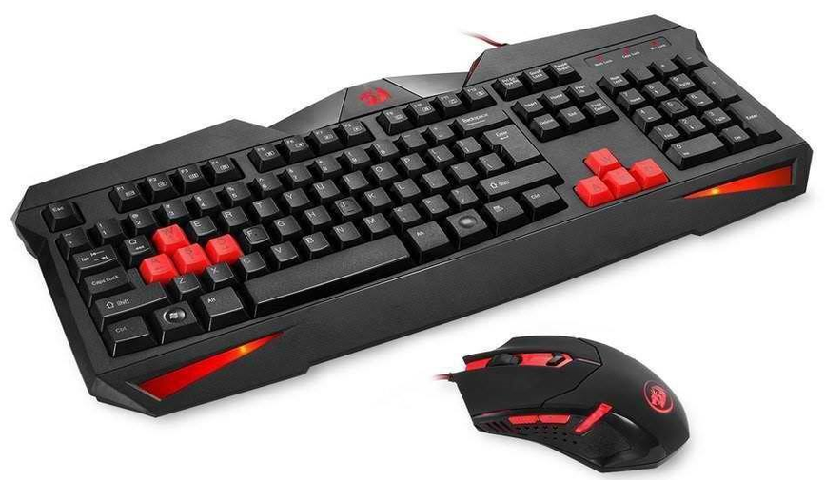
https://media.takealot.com/covers_tsins/45051305/reddragonbundle-zoom.png

Heads up Display (HUD)

HUD is turned to be significant part of the game itself, and nowadays almost all of the game companies are using the all-important elements in the screen in order to simplify the work of the player, and our game - “Frozen Summer: Oghuz Edition” is no exception. Besides the characters and other objects in the game, gamers will be able to see some game changing factors in the monitor, here are the list of some of them[2]:
Health Bar – health bars will be visible for not only chosen player but also other enemies.

Ulti Bar – this bar can be different in variety of characters.

Number of Snowballs – this bar is also can vary in different characters.

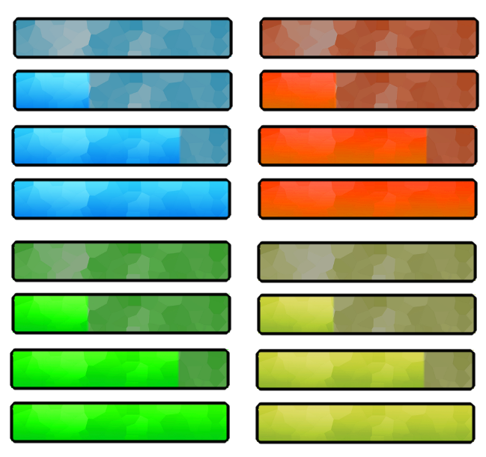
https://i.pinimg.com/originals/3b/97/fc/3b97fc1a260d4b810c7581b97e228fef.png

Player View
Actually, our game is planned to be in the TPs view, which stands for Third-Person Shooter, and as name suggests our main camera will not be showing the same scene from the characters eyes, the gamer will be able to see from the top of the character, and even whole body of the character will be visible. Furthermore, throughout the game our main camera will be following the selected character(in this case it is our character), and some minor zooming in and out may be seen in the starting of the game and in the final scene.

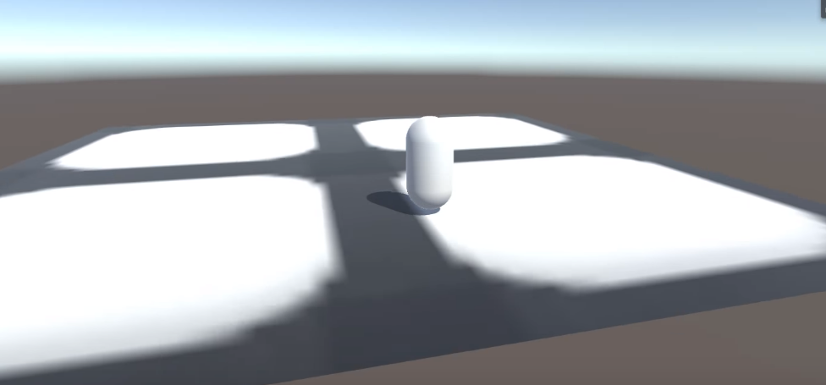

Antagonistic Elements

In our newly developing game - Frozen Summer: Oghuz Edition, there will be several antagonistic elements. In the game, if the gamer is trying to create new game, he or she has to choose one of the main characters, including Basat (001), Beyrek (002) and Bay Beycan (003). However, players are free to choose their game names themselves. In the game, as it is mentioned, user must choose one of the hero; therefore, none of the aforementioned characters cannot be faced during the gameplay. However, they will have some enemies which will try to obstruct and stop them throughout the game. For instance, the Snowmen (008) in the game will always throwing the snowballs towards the player. Moreover, the main enemy of our hero – Simnar Khan (004) is another antagonistic element in our game.

Antagonistic Definitions

In our game, the list of characters that can be chosen by gamers is not enemy to each-other. They cannot be face during the game, while other antagonistic elements, in our case they are Snowmen and Simnar Khan, are always trying to stop our main hero. They always throw snowballs in the game. Not only them but also our main hero are always throw snowballs, therefore all of them can be considered as an antagonistic elements.

Antagonistic Properties
In the game all alive properties will have some common properties. These common properties will be more or less same for all antagonistic elements in the game, while some of the characters will have variety of special skills. Health and number of snowballs in the both enemy and our hero can be good example for this kind of property.

Antagonistic List

Element ID | Name | Description
001 | Basat | One of the game characters that have special ability to move fast
002 | Beyrek | A game character that can shoot multiple snowball at the same time
003 | Bay Becan | A game character that have powerful snowballs
004 | Simnar Khan | Main enemy in the last level that have highest power
008 | Snowmen | Soldiers of the Simnar Khan

Artificial Intelligence (AI)
<Nowadays almost all of the game factories are using AI to make their games more interesting, and without it none of the games can be imagined. Our game is also no exception in terms of AI usage, and in the behaviors of the antagonistic elements we are planning to use AI. All of the above-mentioned states are for Snowmen which are main opponents of the gamer, and will be controlled by the computer with help of AI:
- Normal State: If the enemies are far away from the main hero, they will be in the normal state. This state also can be considered as an idle state, because in this state enemies are not doing anything but walking without any damage.
- Detection State: In the game snowmen are humanlike elements, while their eyes are not as good as normal person, therefore they only can detect our here if it enters the vision range of snowmen.
- Reaction State: If the character is in the vision range, and detected by the arbitrary snowman, they will immediately be under attack of the snowmen. Snowmen will start moving towards the hero and start to throw snowballs.
- End State: After snowball fight either hero or snowmen will win the fight, in case of their winning snowmen will pass to idle state again and game will be finished for the gamer.

Global Game Elements
<In this section, it is important to describe the boundaries, neutral objects, camera views and scale of the world. Neutral game world objects can be things like a static background, objects that do not interact with the player or antagonistic elements.>

The Story
In the beginning, the user will have ability to choose main player among 4 characters, and it should be mentioned that all characters have their own special skills and gamers can take any skill combination they want. After all, the game is ready to start. Firstly, game begins with short explanation about the situation. All events are happening in the campus of ADA University that located in the mythical Cirdaxanli village. Some mystical changes occurred in the village, and unexpected snow drastically affected citizens of Cirdaxanli village in the middle of the summer. All places are under snow and all people are frozen, except Uruz, and his fiancé Banuchichek. Banuchichek was kidnapped by some unknown people. After realizing seriousness of the situation, Uruz is looking for ways to solve the issue, and he calls his cousin from Siberia to help. Thence, our adventure is ready to go. The chosen player in this scenario Uruz’s cousin (Bay Becan) tries to find the reason behind of the sudden change. However, there is one big problem - snowmen. Because their life directly depends on a cold weather, they try their best to prevent the Bay Becan and start snowball fight against our hero to make our main player freeze forever.
This game initially consist of 4 levels and each level has its own secret item inside the box. In addition, difficulty of game increases while level is going up. In the first level Uruz encounter with easy first level snowmen. After defeating the first level (easy) snowmen Uruz finds a string (Sim) and a pot (Qazan) inside the coffer and adds it to his loot box. Later all collected items will be used to solve a puzzle at the end of third level and this will help player to gain access to the final level. In the second level main player fights against more powerful snowmen, and after defeating them, Uruz finds a pomegranate (Nar) inside the coffer. He again adds this into his loot box. In the third level after defeating the most powerful snowmen he finds a crown.
Then new window pops up in the game screen, and the user has to connect all items and solve the puzzle for gaining access to the final level. After connecting all elements from different levels (a string, a pot, a pomegranate, a crown) he discovers that Simnar Khan and Qazan Khan gave order snowmen to kidnap fiancé Banuchichek. At the final level, Uruz fights against Simnar Khan and Qazan Khan and defeat them. At the end he rescues his fiancé and life comes back to the normal in his village.

The Story Copy
Three main characters: Bay Becan, Basat, Beyrek have their own special ability such as speed, power, etc. Our game is going to be level based, in first level the main character will face with bunch of snowmen with low power. After defeating them succefully in a given time, the main character will have access to the second level. In the second level amount of snowmen and their power will be increased. Third level also going to be similar to the second level but a little bit harder version. In the last level. The main character have to fight against most powerful enemy Simnar khan along with snowmen in order to finish the game by saving Banuchichek.

Concept Art

1) We are planning to make main menu look like in the Figure 1. In the new game section the user will start a game with a chosen character. Data load section will allow user to continue from where he/she left. In the configuration section user will be able to change sound, display quality and other settings. Name change section will allow user to change his/her nickname.

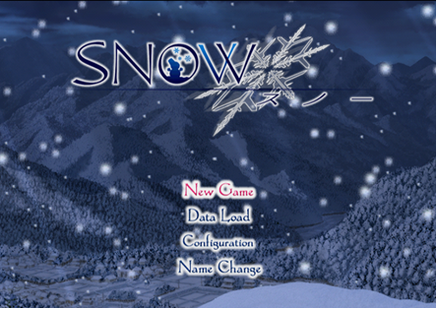

2) This 3D model of Flame towers of Azerbaijan will be included in our game’s map. The user may use buildings as a shield to protect themselves from snowball shootings

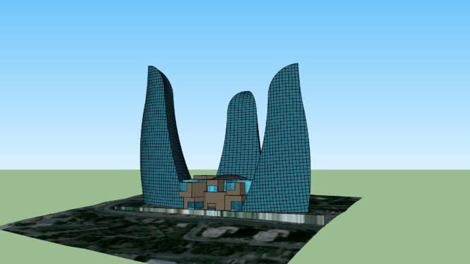

3) 3D model of main enemy character “Snowman” will be included our game.

Several trees also is also going to be added our game

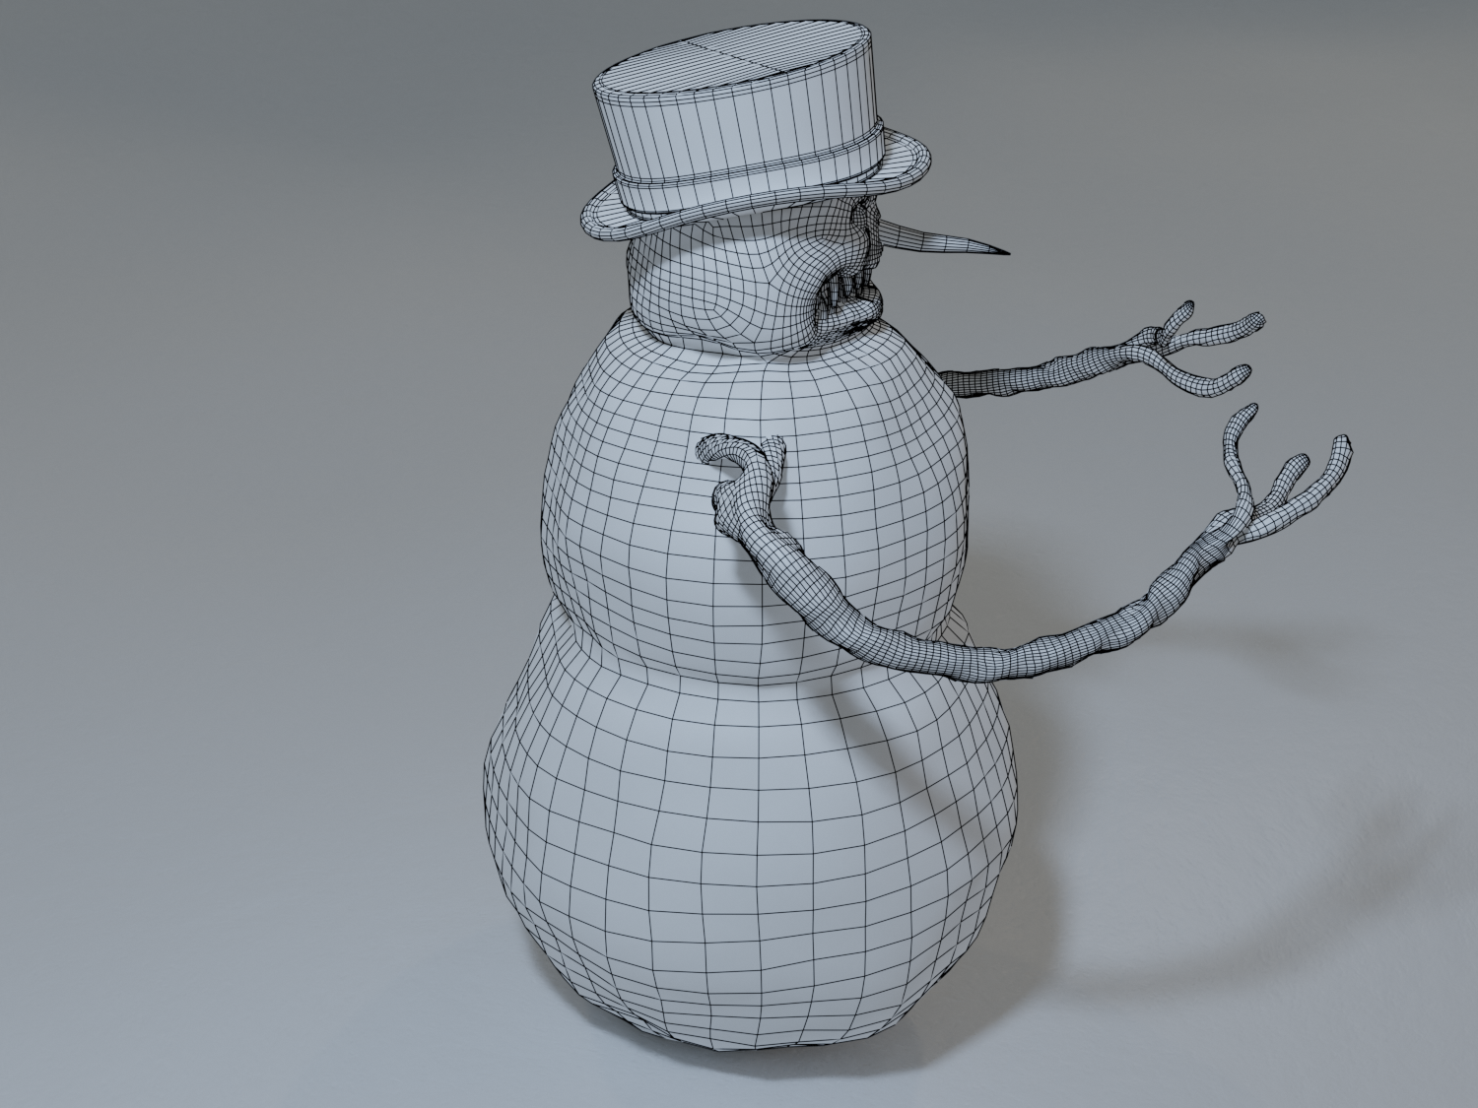

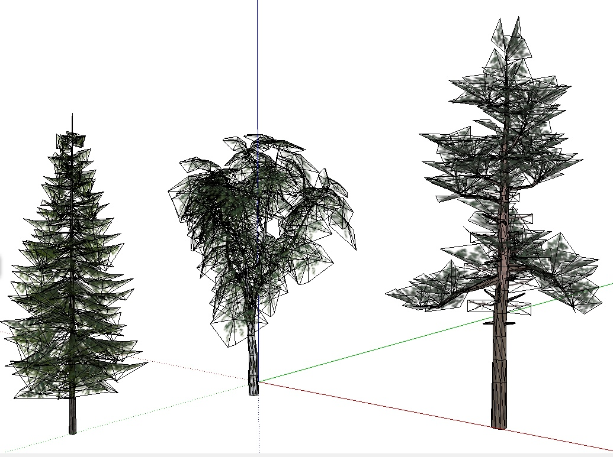

Level Design
Since Frozen Summer will be level-based game, there will be different events in each level. We will increase difficulty of the game while level increasing and reward the players with extra scores.

Level Copy
<This is where the script for in game characters or story information during the cut scenes would be placed.>

Audio & Sound F/X
All the players and some objects will have their own sound. Each character will have different step sound. When players hit each other there will be special sound for that.

Game Architecture
<The game architecture section is best produced using a flow chart to represent the overall game. Be sure to identify (i.e. name, number) each screen.
- Title Screen
- Option Screens
- Game Modes
- End Screens
>

Game Architecture Overview
<The splash screens or video clips need to be in accordance to game story and style. If cut scenes use video then story boards should be created.
Menus should be designed with the most important options easily accessible. Be aware how many clicks it takes to accomplish a task. The game Instructions should be written so that the player understands how to play the game. Mock-ups should be made so that the game programmers get the correct layout of the menu. It is a good idea to mention and describe the high score screen in this section.>

Architecture Copy
<All text from the game can be compiled here. Review the Game Architecture Overview section.>

How to Play Copy
<This section will organize the game copy. The game copy includes information for the player, clearly describing how to play the game.>

References
<Insert here any document referred to in the document. An example might be articles or Web sites that you consulted during the literature search. This is not just a list of used materials, so do not forget to clearly MARK the exact points(s) of reference in the main text.>

